This tutorial was conducted on a Multipass instance.

**Step 1: Prepare the environment**

Ensure the system is up to date using command:

$ sudo apt update

Upgrade all system’s packages to the latest version, flag -y used to automatically approve the upgrade

$ sudo apt upgrade -y

Install OpenJDK 11 – Java development toolkit for running Java applications (Java Runtime Environment) and developing Java applications (Java Development Kit)

$ sudo apt install openjdk-11-jdk -y

To verify your installation, use command:

$ java -version

**Step 2: Create user “khtn_22120210”**

Create user “khtn_22120210”, using command:

$ sudo adduser khtn_22120210

To grant superuser privileges to the new user, add them to the sudo group using the following command:

$ sudo usermod -aG sudo khtn_22120210



As you can see, when using command $ groups khtn_22120210, user “khtn_22120210” have an alias “sudo”.

Upon completion, switch to the user “khtn_22120210”using command:

$ sudo su – khtn_22120210



**Step 3: Download Hadoop**

Download Hadoop 3.3.6 from Hadoop’s official website using command:

$ wget https://dlcdn.apache.org/hadoop/common/hadoop-3.3.6/hadoop-3.3.6.tar.gz

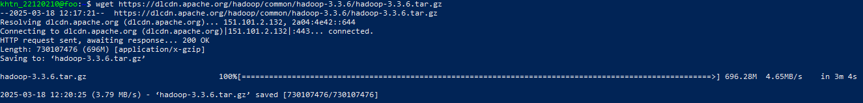

Extract Hadoop using command:

$ tar -xvzf hadoop-3.3.6.tar.gz

Check whether we are currently in the same directory as hadoop-3.3.6 (default: ***/home/khtn_22120210***). If so, move the files to ***/usr/local/hadoop*** using the following command:

$ sudo mv hadoop-3.3.6 /usr/local/hadoop



Create a directory to store logs by using:

$ sudo mkdir /usr/local/hadoop/logs





Alter the ownership of the ***/usr/local/hadoop*** directory to the user “khtn_22120210” using following command:

$ sudo chown -R khtn_22120210 /usr/local/hadoop



**Step 4: Create SSH key**

Install the OpenSSH server and client:

Use the subsequent command to generate both private and public keys (it’s important not to set the passphrase):

$ ssh-keygen -t rsa

Add the public key to *authorized_keys* using command:

$ cat ~/.ssh/id_rsa.pub >> ~/.ssh/authorized_keys

Using the following command change the file permissions of authorized_keys:

$ sudo chmod 640 ~/.ssh/authorized_keys

Start the SSH service:

$ sudo service ssh start

Confirm the SSH configuration:

$ ssh localhost

**Step 5: Configuring Hadoop’s environmental variables**

Open configuration file using command:

$ nano ~/.bashrc

Move to the end of the file using Ctrl + / then Ctrl + V

Paste Hadoop’s configuration at the end of the file:

export JAVA_HOME=/usr/lib/jvm/java-11-openjdk-amd64  
export HADOOP_HOME=/usr/local/hadoop  
export HADOOP_INSTALL=$HADOOP_HOME  
export HADOOP_MAPRED_HOME=$HADOOP_HOME  
export HADOOP_COMMON_HOME=$HADOOP_HOME  
export HADOOP_HDFS_HOME=$HADOOP_HOME  
export HADOOP_YARN_HOME=$HADOOP_HOME  
export HADOOP_COMMON_LIB_NATIVE_DIR=$HADOOP_HOME/lib/native  
export PATH=$PATH:$HADOOP_HOME/sbin:$HADOOP_HOME/bin  
export HADOOP_OPTS="-Djava.library.path=$HADOOP_HOME/lib/native”

Save the changes by pressing Ctrl+S and exit the *nano*text editor by pressing Ctrl+X

To enable the changes, source the *.bashrc*file using command:

$ source ~/.bashrc



Check for Hadoop version using command:

$ hadoop version

**Step 6: Config Hadoop**

Define java environment variables in *hadoop-env.sh* file:

To open *hadoop-env.sh* file use the command:

$ sudo nano $HADOOP_HOME/etc/hadoop/hadoop-env.sh

To search for the “export JAVA_HOME” phrase use Ctrl + W

And change it as below:

export JAVA_HOME=/usr/lib/jvm/java-11-openjdk-amd64

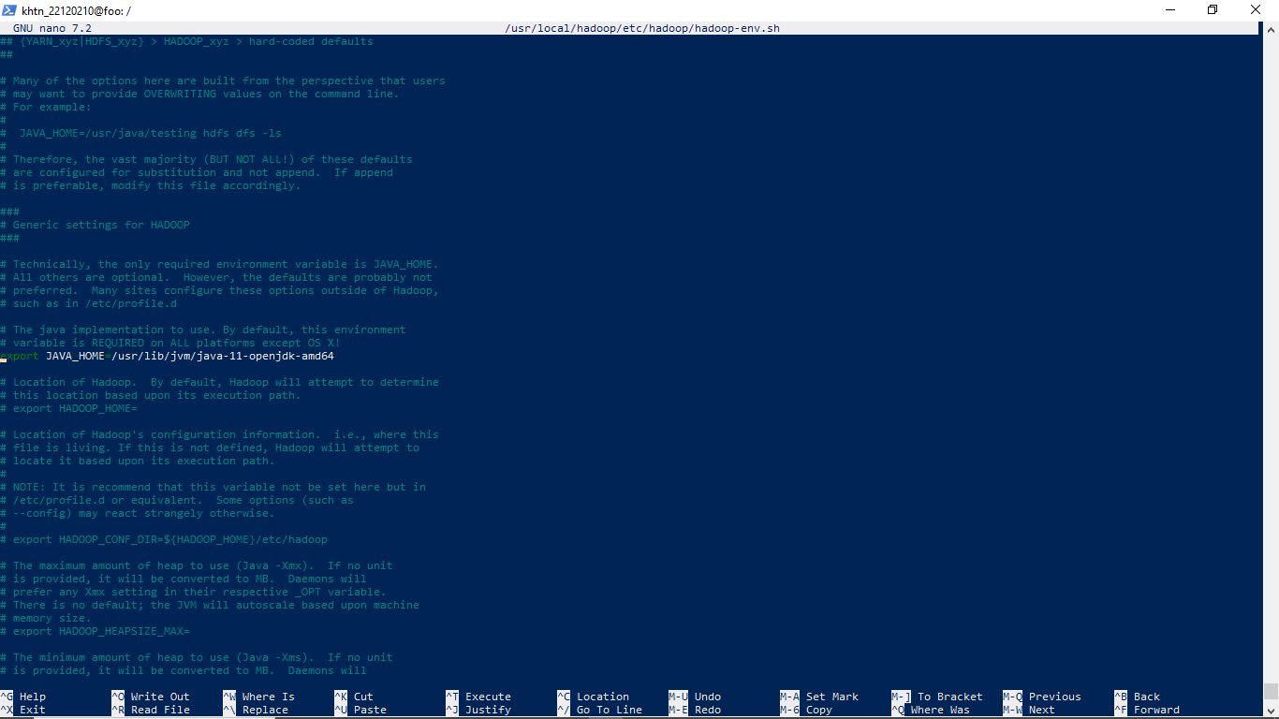

Configuring Hadoop to Pseudo-Distributed Mode:

Open file *core-site.xml* to configure HDFS using command:

$ sudo nano $HADOOP_HOME/etc/hadoop/core-site.xml

Add the following lines between <configuration> </configuration>

<property>

<name>fs.defaultFS</name>

<value>hdfs://localhost:9000</value>

</property>

(To edit the file press Ctrl + Y, then Ctrl + V to go to the end of file and right-click to paste those above properties in place)

Then press Ctrl + S to save the file then Ctrl + X to exit

Create a directory to store node metadata using the following command:

$ sudo mkdir -p /home/hadoop/hdfs/{namenode,datanode}



Grant the ownership of the created directory to the “khtn_22120210” user:

$ sudo chown -R khtn_22120210 /home/hadoop/hdfs



Open file *hdfs-site.xml* to configure data storage folder, using command:

$ sudo nano $HADOOP_HOME/etc/hadoop/hdfs-site.xml

Add the following properties between <configuration> </configuration>

<property>  
 <name>dfs.replication</name>  
 <value>1</value>  
</property>

<property>  
 <name>dfs.name.dir</name>  
 <value>file:///home/hadoop/hdfs/namenode</value>  
</property>

<property>  
 <name>dfs.data.dir</name>  
 <value>file:///home/hadoop/hdfs/datanode</value>  
</property>

Open file *mapred-site.xml* to configure MapReduce mode (default is Standalone Mode), using command:

$ sudo nano $HADOOP_HOME/etc/hadoop/mapred-site.xml

Add the following lines between <configuration> </configuration>

<property>  
 <name>mapreduce.framework.name</name>  
 <value>yarn</value>  
</property>

Open file yarn-site.xml to configure auxiliary service (default is Standalone Mode), using command:

$ sudo nano $HADOOP_HOME/etc/hadoop/yarn-site.xml

Add the following lines between <configuration> </configuration>

<property>  
 <name>yarn.nodemanager.aux-services</name>  
 <value>mapreduce_shuffle</value>  
</property>

Format HDFS’ namenode, using command:

$ hdfs namenode -format

After starting YARN and DFS on “foo,” I realized that I hadn’t allocated enough RAM to the virtual machine. As a result, “foo” would not be able to handle other tasks needed to complete this lab. Therefore, I will create a new instance called “bigdata” and use it as an alternative. All setups are similar to the tutorial shown above.

**Step 7: Start Hadoop**

To verify running services, using command:

$ jps

Now you can use the provided Hadoop UI. **Note:** If you set up the environment on a virtual machine, use the VM's IPv4 address instead of **localhost** to access Hadoop’s web services. As shown below, my instance’s IPv4 address is **172.22.235.75**.



**Step 8: File manipulation with Hadoop**

Use the following commands to create a directory for hadoop-test.jar on HDFS:

$ hdfs dfs -mkdir /hcmus

$ hdfs dfs -mkdir /hcmus/22120210



Verify the owner of the directory:



khtn_22120210 is the creator also owner of the directory so it is not necessary to change the owner

To transfer file between host and instance “bigdata”, open Windows Powershell with Administrator previllige and type the following command:

multipass transfer "E:\hadoop-test.jar" bigdata:/home/ubuntu

After that move the file to ***/home/khtn_22120210***, using command:

$ sudo mv hadoop-test.jar /home/khtn_22120210

Verify the transfer:



Upon completion, use the following command to upload file on HDFS:

$ hdfs dfs -put hadoop-test.jar /hcmus/22120210

Verify if the file was uploaded successfully:

You can also use the web service UI to upload the file:

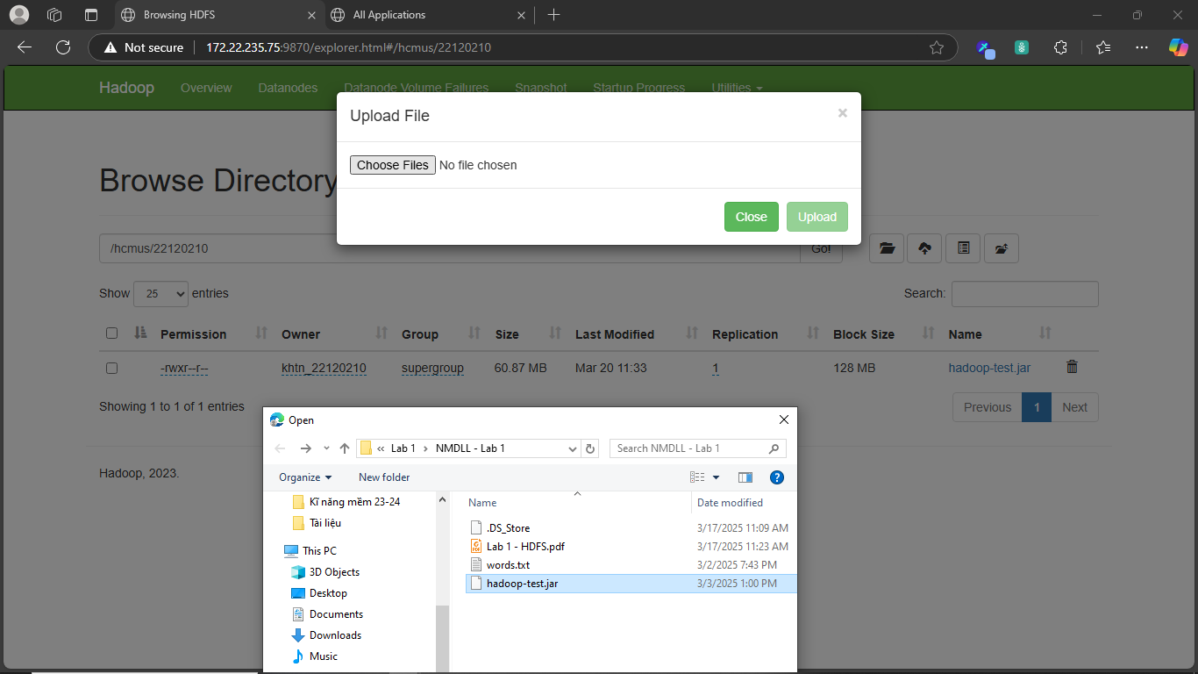

Change the file permission to execute the file on hdfs:

$ hdfs dfs -chmod 744 /hcmus/22120210/hadoop-test.jar

**Step 9: Run the programme**

To execute the file, use command:

$ java -jar hadoop-test.jar 9000/hcmus/22120210

Verify the result:

